PENETRATION TESTING REPORT
FOOTPRINTING & NETWORK SCANNING PHASES
W2-PM-FINAL | CYBERSECURITY | NETWORKWALKS

Pentester Name  (Cybersecurity Professional) | Michael Tetteh
Program/Batch | B083-Networkwalks
Date | 16th September 2026
Modules completed | W2-PM1 (Footprinting with WHOIS & DNS Tools)  W2-PM2 (Footprinting & reconnaissance attacks with GHDB)  W2-PM3 (Footprinting with maltego)  W2-PM5 (Zenmap Scanning)
Client/Target | 1. Networkwalks (secured written permission already)  2. My own local LAN Network
Permission secured from client? | Yes
Phases covered | Phase 1: Reconnaissance & Footprinting  Phase 2: Scanning & Network Discovery  Phase 3-5: In Progress

1. Liability Disclaimer
Only systems and devices that I personally own or where I have specific written permission to conduct security testing have I engaged in these activities. This report's content is solely intended for educational and research purposes.
Nothing in this place should be used to violate the law. The individual bears full responsibility for the application of this knowledge. A permanent record, severe penalties, job loss, and criminal prosecution are all possible outcomes of misuse. Unauthorized access is illegal in the majority of jurisdictions, even if no harm is done.
Any misuse of the information in this report is not the responsibility of Networkwalks, the teacher, or the authors.

2. Introduction
By mimicking actual attacks, penetration testing is a methodical procedure used to assess the security posture of networks and systems. Because they offer insight into the target environment prior to any attempts at exploitation, the initial phases of this process—footprinting and network scanning—are crucial.
For this study, I used approved systems and my own lab setting for regulated penetration testing exercises. Using tools like WHOIS, DNS utilities, GHDB, Maltego, and Zenmap, the emphasis was on data collection and network reconnaissance.
The objectives of this report are to:
- Record the modules that were finished in the second week of the cybersecurity course.
- Show how domain, DNS, and OSINT information may be found using footprinting techniques.
- Describe how network scanning finds services, IP addresses, MAC addresses, and live hosts within a subnet.
- Highlight the importance of these steps in both offensive security testing and defensive monitoring.

This report was created as part of W2-PM-FINAL | Cybersecurity | Networkwalks, and all activities were carried out responsibly, with permission, and solely for educational purposes.

3. Tools Used
The table below lists each tool used in this report and its purpose.
Tool | Purpose
Kali Linux & Windows | Operating systems used for reconnaissance and scanning activities
WHOIS | Find domain registration details (owner, dates, name servers)
nslookup | Resolve domain names to IP addresses using DNS
dnsrecon | Enumerate all DNS records (NS, MX, SPF, TXT, SRV)
whatweb | Fingerprint web technologies (server, CMS, plugins, IP)
curl -I | Read HTTP response headers of a website
wafw00f | Detect whether a Web Application Firewall protects the site
GHDB | Perform reconnaissance using Google hacking queries to find sensitive info
Maltego | Graphical link analysis to map relationships between domains, emails, and infrastructure
theHarvester | Enumerate emails, subdomains, and hostnames using OSINT
Zenmap (Nmap GUI) | Scan the local subnet to find live hosts, IPs, MAC addresses, and services

4. Activities Performed

4.1 Footprinting & Reconnaissance (Footprinting with WHOIS & DNS Tools)
Using six Kali Linux tools WHOIS, WhatWeb, Nslookup, Curl, Wafw00f, and DNSRecon I conducted reconnaissance against the networkwalks.com domain. Different kinds of information on the target were gathered using each instrument.
I began by locating the domain's name servers and gathering publicly available domain registration data using WHOIS. The results included information about the registrar, registration dates, and hosting infrastructure.
I then used WhatWeb to determine which technologies the website was using. The results revealed that the site was running WordPress x.0.x with the WP Download Manager x.x.xx plugin, along with other technologies exposed by the web server.
I was able to resolve the domain name to its IP address using Nslookup. The outcome verified the server location by identifying the host IP as xxx. xxx. xxx. xxx.
I examined the HTTP response headers using Curl and the -I option. This revealed more details about the web application, such as cookies, cache policies, and the exposed WordPress REST API endpoint /wp-json/.
I then used Wafw00f to check if the website was protected by a Web Application Firewall. The scan verified that the website had some degree of defense against online threats by identifying ModSecurity (SpiderLabs) as the active WAF.
Lastly, I enumerated DNS records using DNSRecon. A comprehensive image of the domain's DNS infrastructure was supplied by the results, which included details regarding name servers, mail servers, SPF/TXT records, service records, and DNS software.
Why This Matters
- Network Visibility: Discloses the DNS configuration, hosting company, and registrar for the domain.
- Attack Surface Mapping: This method finds DNS records, plugins, and technologies that could be abused if they are out-of-date or incorrectly configured.
- Defensive Awareness: Assists administrators in configuring WAF protections, patching CMS plugins, and securing DNS records.

4.2 Footprinting with GHDB (Google Hacking Database)
I performed reconnaissance using the Google Hacking Database (GHDB) to identify publicly exposed resources indexed by Google. GHDB queries, also known as Google dorks, are advanced search operators that reveal misconfigured systems, sensitive files, and hidden directories. For this task, I focused on two objectives:

Locating active security camera links that are open to the Internet.

Finding PDF eBooks about mathematics that can be downloaded.

Task 1 — Vulnerable Security Cameras
To find unprotected webcam streams, I used GHDB queries like intitle="webcamXP" inurl:8080 and variations. Devices using webcam streaming software on default ports are the target of these queries. Several live camera sites that may be accessed without authentication were found in the findings.
No. | Link | Relevant Dork | Username/Password
1 | http://xxx.116.xxx.8:8080/ | intitle:"webcamXP" inurl:8080 | ---
2 | http://xxx.233.191.130:8080/ | intitle:"webcamXP" inurl:8080 | ---
3 | http://72.xxx.200.5:8080/ | intitle:"webcamXP" inurl:8080 | ---
4 | http://xxx.64.168.xxx:8080/ | intitle:"webcamXP" inurl:8080 | ---
5 | http://xxx.93.53.xxx:8080/ | intitle:"webcamXP 5" inurl:8080 'Live' | ---
6 | http://xxx.206.54.xxx/ | Display Cameras intitle:"Express6 Live Image" | ---
7 | http://xxx.149.26.xxx:1024/ | intitle:"webcamXP 5" inurl:8080 'Live' | ---
8 | http://xxx.206.xxx.75:8080/ | intitle:webcam 7 inurl:8080 -intext:8080 | ---
9 | http://xxx.255.xxx.164:8080/ | intitle:webcam 7 inurl:8080 -intext:8080 | ---
10 | http://xxx.115.xxx.130:32479/ | intitle:webcam 7 inurl:8080 -intext:8080 | ---
11 | http://xxx.149.26.xxx:1024/ | intitle:"webcamXP 5" -download | --

Task 2 — Downloadable Mathematics eBooks

I used GHDB queries such as intitle:index.of "parent directory" mathematics pdf to locate directories containing mathematics eBooks in PDF format. These queries reveal open directory listings where files are directly accessible.
No. | Link | Relevant Dork | Username/Password
1 | https://www.skylineuniversity.ac.ae/pdf/math/ | intitle:index.of "parent directory" mathematics pdf | ---
2 | https://www.unm.edu/~megrad/Math/ | intitle:index.of "parent directory" mathematics pdf | ---
3 | https://education.giakonda.org.uk/Maths/ | intitle:index.of "parent directory" mathematics pdf | ---
4 | https://www.jsoftware.com/books/pdf/ | intitle:index.of "parent directory" mathematics pdf | ---
5 | https://math.dartmouth.edu/~carlp/PDF/ | intitle:index.of "parent directory" mathematics pdf | ---
6 | https://www.netlib.org/math/docpdf/ | intitle:index.of "parent directory" mathematics pdf | ---
7 | http://inis.jinr.ru/sl/vol2/Mathematics/Math.Encyclopedia/Pdf/ | intitle:index.of "parent directory" mathematics pdf | ---
8 | https://www.learn-fo.com/FYUG%20mathematics%20solutions/?SD | intitle:index.of "parent directory" mathematics pdf | ---
9 | https://www.math.utah.edu/~cherk/teach/5740MathModeling/12mathmodel/sources/ | intitle:index.of "parent directory" mathematics pdf | ---
10 | https://pcwww.liv.ac.uk/maths/ | intitle:index.of "parent directory" mathematics pdf | ---
11 | https://naac.matagujricollege.org/Syllabus/2016-17/Mathematics/syllabus2016-17/ | intitle:index.of "parent directory" mathematics pdf | ---

Why This Matte

Network Visibility: Shows the amount of sensitive content that search engines openly index.

Attack Surface Mapping: Open directories and exposed webcams are possible points of entry for attackers.

Defensive Awareness: Emphasizes the necessity for businesses to safeguard devices, limit directory listings, and stop sensitive resources from being indexed by search engines.

4.3 Footprinting with Maltego.
I used Maltego, a potent open source intelligence (OSINT) and link analysis tool, to conduct reconnaissance on the networkwalks.com domain. Investigators can see relationships between domains, IP addresses, email addresses, and other entities in a graphical way with Maltego.
I started by launching a new Maltego project with the desired domain networkwalks.com. After that, I performed a number of transformations to obtain relevant data.
Along with related name servers and mail servers, the IP address linked to the domain was disclosed by the DNS transformations. This gave information about the email route configuration and hosting architecture.
I then extracted registrar and ownership information using Maltego's WHOIS transforms. This highlighted administrative connections and verified the domain registration details.
In an effort to list all publicly accessible email addresses connected to the domain, I also performed email address transformations. In the context of penetration testing, these findings may be helpful for social engineering or phishing simulations.

Lastly, I identified related domains and subdomains using infrastructure transforms. The relationships between the target domain and other assets were visually represented by Maltego's graph view.

Why This Matters

Network Visibility: Maltego offers an easy-to-understand visual representation of the connections between domains, IPs, and emails.

Attack Surface Mapping: Finding linked domains and subdomains broadens the reconnaissance's reach and highlights possible vulnerabilities.

Defensive Awareness: Maltego allows administrators to inspect their own infrastructure and find unwanted exposures.

4.5 Network Scanning with Zenmap
Using Zenmap, the Nmap graphical user interface, I conducted active reconnaissance against the xxx. xxx. xxx.0/xx subnet. Finding live hosts, determining IP and MAC addresses, and mapping the local network architecture were the main goals of this phase.
First, I determined the IP address, subnet mask, default gateway, and physical (MAC) address of my own system using the Windows command prompt (ipconfig /all).
According to the results, my computer was located at xxx. xxx. xxx.5, with a default gateway of xxx. xxx. xxx.1 and a subnet mask of xxx. xxx. xxx. This verified that the scan's scope was a /24 network, which implies that up to 254 hosts might be active.
Next, I executed the Nmap scan with the command: nmap -T4 -f xxx xxx. xxx.0/XX
The scan completed in approximately 18 seconds and reported 5 live hosts within the subnet.
The live hosts discovered were:
- xxx.xxx.100.1 → Router (Huawei Technologies)
- xxx.xxx.100.3 → Windows PC (Intel Corporate)
- xxx.xxx.100.5 → My PC (Intel Ethernet Adapter)
- xxx.xxx.100.6 → Host running HTTP/Nessus services (VMware virtualized)
- xxx.xxx.100.7 → Additional LAN device
I then examined the MAC addresses associated with each host. The results confirmed vendor information:
- xxx. xxx.100.1 → C8:3A:35:XX:XX:XX (Huawei Technologies)
- xxx. xxx.100.3 → E4-B9-7A:xxx:xx:xx (Intel Corporate)
- xxx. xxx.100.5 → E4-B9-7A:XXX:XX:XX (Intel Ethernet Adapter – my PC)
- xxx. xxx.100.6 → 00:0C:29:XX:XX:XX (VMware/Virtualized host)
- xxx. xxx.100.7 → F4:8E:38:XX:XX:XX (LAN device vendor)
Finally, I exported the Zenmap topology view into a PDF format. This visualized the subnet as a star topology, with the router at xxx. xxx.100.1 acting as the central gateway, and the other hosts branching out as connected nodes.

Why This Matters

Network Visibility: Verifies the active devices in the subnet and their connections.

Attack Surface Mapping: Every active host is a possible port of entry for hackers.

Defensive Awareness: Administrators are able to keep an eye on these hosts, protect services that are exposed, and identify unapproved devices.

5. Risk Analysis / Impact
I determined the following possible dangers based on the data gathered during the network scanning and footprinting operations. These dangers are not verified vulnerabilities; rather, they are findings from reconnaissance and scanning operations.
# | Risk / Finding | Evidence / Observation | Potential Impact | Risk Level
1 | Web technology information exposed | WhatWeb identified WordPress x.xx.x and WP Download Manager x.x.x | Attackers may use exposed technology/version information to identify software requiring further security review | ● Medium
2 | Server IP address identifiable | Nslookup resolved the domain to xxx. xxx.xxx. xxx | Provides information about the network location of the web service | ● Low
3 | HTTP technical information exposed | Curl returned HTTP response headers and exposed /wp-json/ | May assist technology fingerprinting and further enumeration | ● Low
4 | WAF technology identifiable | Wafw00f identified ModSecurity (SpiderLabs) | Reveals information about the web application’s security architecture | ● Low
5 | DNS infrastructure information exposed | DNSRecon identified DNS, mail, and service-related records | DNS information can help build a broader infrastructure profile | ● Medium
6 | Multiple live hosts visible on local network | Zenmap identified 5 live hosts in the subnet | Unknown or unauthorized devices may potentially be present on a network | ● Medium

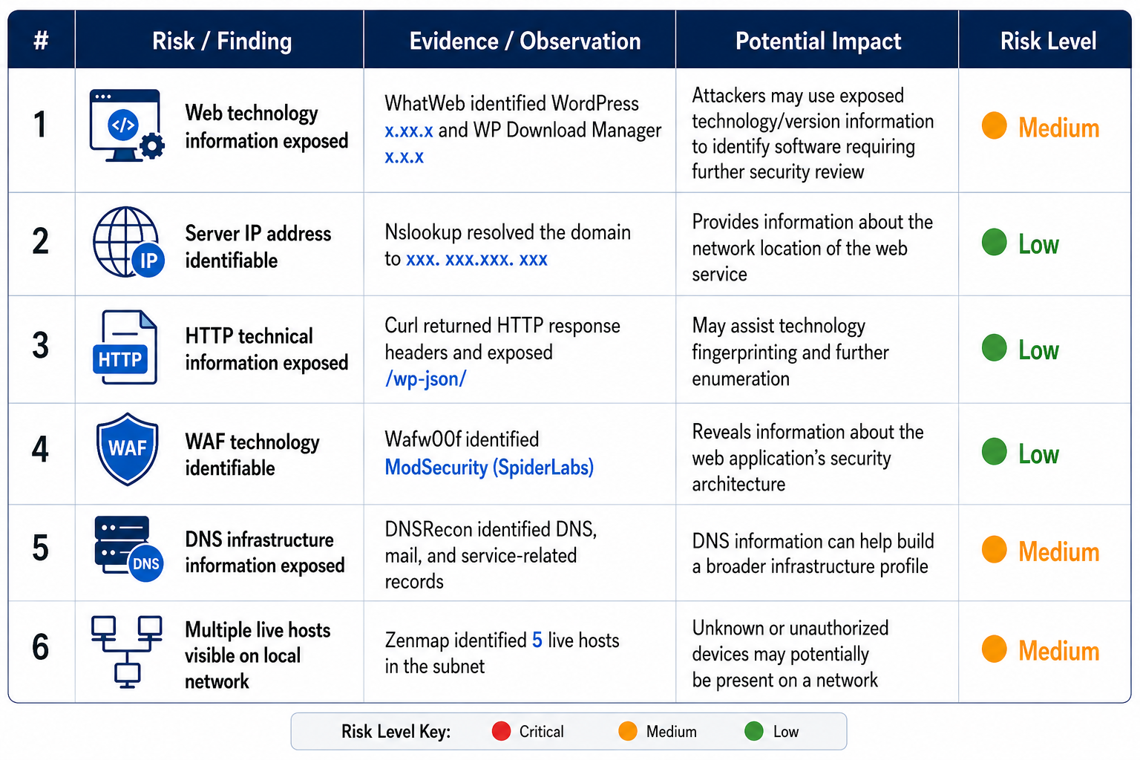

Important Notes
- The dangers listed here are not verified vulnerabilities; rather, they are findings from scanning and footprinting efforts.
- Information collecting and host discovery were the main tasks of these hands-on activities.
- These modules did not include any exploitation or vulnerability validation.
- The existence of data like an IP address, DNS record, or software version does not automatically indicate that the system is vulnerable.
- To verify any real vulnerabilities, more approved security testing would be necessary.

6. Recommendations
Based on the observations from these activities, I recommend the following security improvements:
- Implement continuous monitoring: To identify anomalous activity early, organizations should regularly monitor their networks, systems, and applications.
- Implement stringent patch management: To lessen exposure to known vulnerabilities, keep operating systems, CMS platforms, plugins, and network devices up to date with the most recent security updates.
- Limit information disclosure: Examine which technical details such as software versions, DNS data, and HTTP headers are accessible to the public and reduce needless exposure.
- Strengthen access restrictions: To prevent unwanted access, enforce role-based access, rigorous authentication, and frequent credential reviews.
- Infrastructure for secure networks: Maintain precise network topology documentation, conduct routine internal network scans, and look into unidentified devices.
- Install and maintain preventive technologies: To prevent common attack vectors, configure and keep an eye on endpoint security solutions, intrusion detection systems, and Web Application Firewalls (WAF).
- Carry out approved penetration testing: To verify security safeguards and find weaknesses before attackers may take advantage of them, conduct authorized penetration testing on a regular basis.
- Raise awareness of security: Educate employees on safe handling of sensitive data, phishing awareness, and cybersecurity best practices.

7. Conclusion
The footprinting and network scanning stages of penetration testing were given an organized method by this project. I was able to use a range of reconnaissance methods and instruments to obtain information about the target domain and local network environment by finishing modules W2 PM1 through W2 PM5.
The exercises showed how important details about a system's infrastructure may be found using programs like WHOIS, WhatWeb, Nslookup, Curl, Wafw00f, DNSRecon, GHDB, Maltego, and Zenmap. DNS records, web technologies, exposed endpoints, subdomains, email addresses, and active hosts inside a subnet were among the findings.
Although these findings do not constitute verified vulnerabilities, the risk analysis made clear that they do reveal important information that may be exploited by attackers. Patch management, reducing information disclosure, keeping an eye on DNS and HTTP setups, protecting network infrastructure, and carrying out authorized penetration testing are all stressed in the guidelines.

All things considered, this study reaffirmed the significance of the information collection phase in cybersecurity. Despite being the cornerstone of each penetration test, reconnaissance is frequently undervalued. Organizations can take proactive measures to lower their attack surface and bolster their defenses by knowing what data is publicly accessible and what devices are active on a network.8. Evidences Collected
Figure 1 Whois info on networkworks
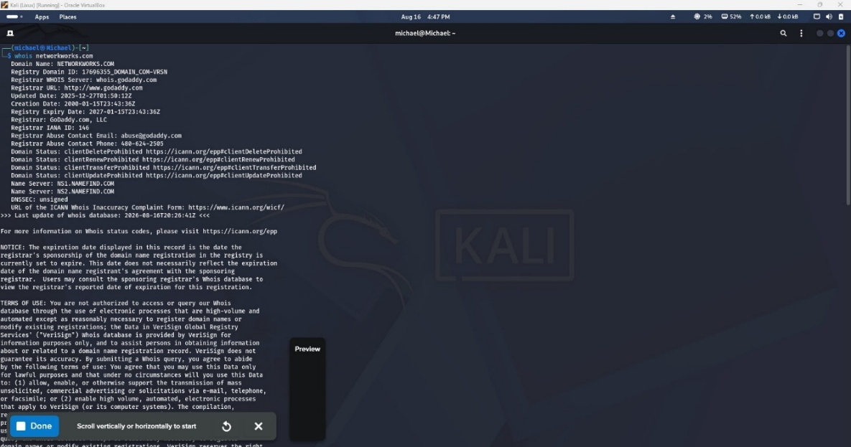

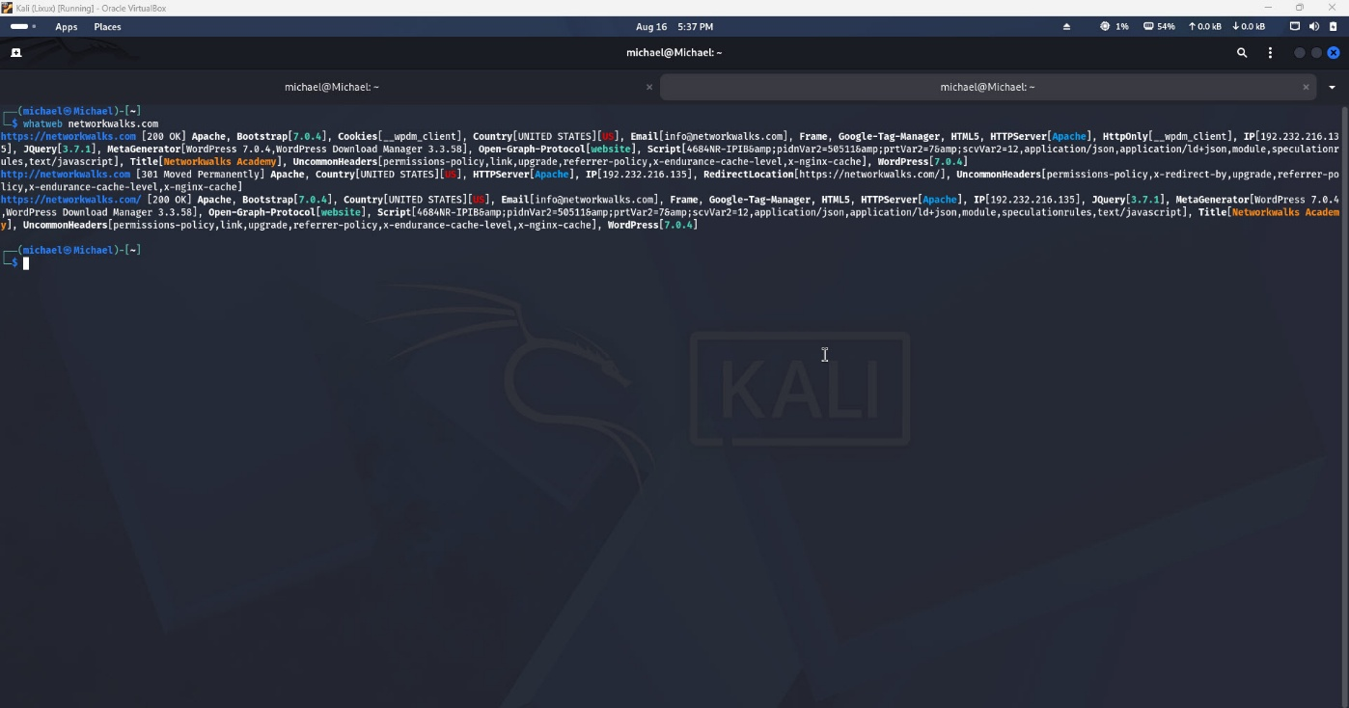
Figure 2 WhatWeb info scan on Networkworks

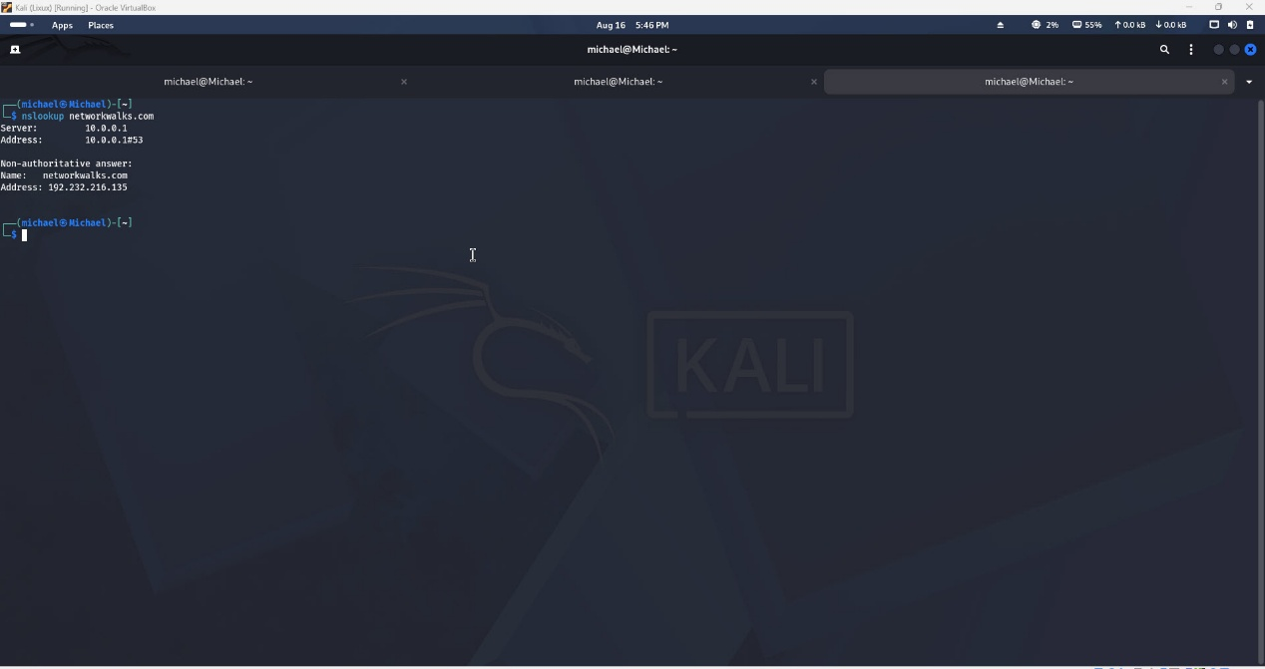
Figure 3 nslookup result
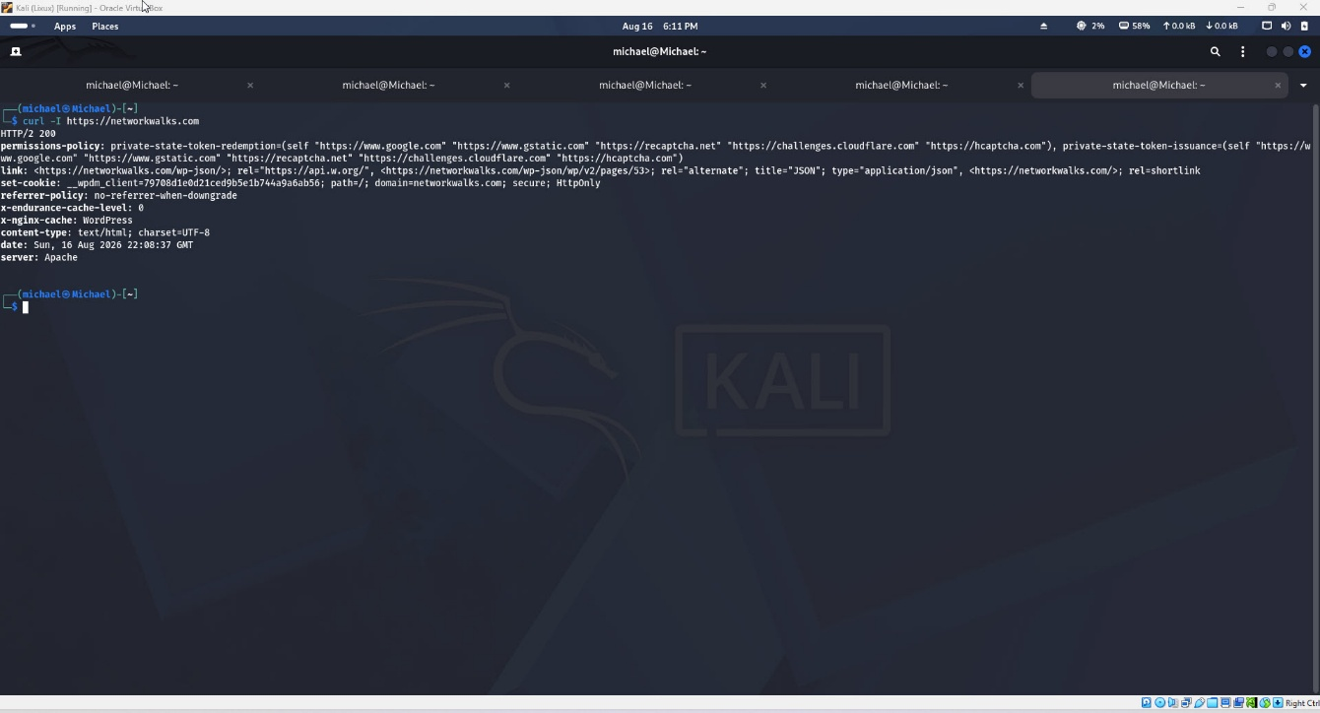
Figure 4 curl networkworks

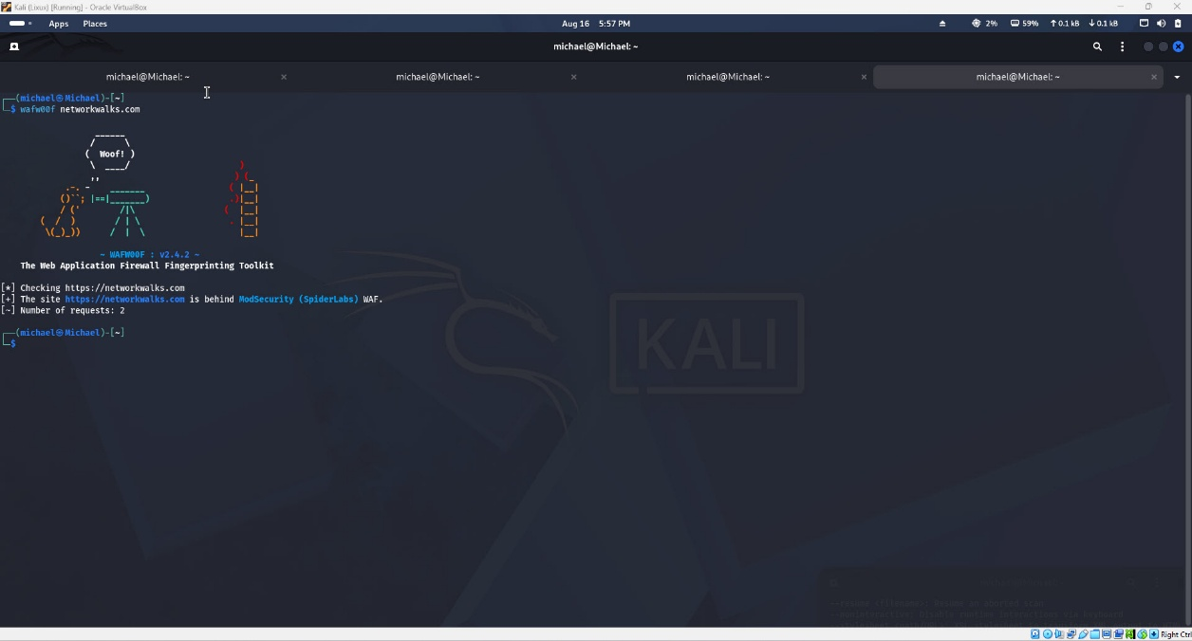
Figure 5 wafw00f Scanning

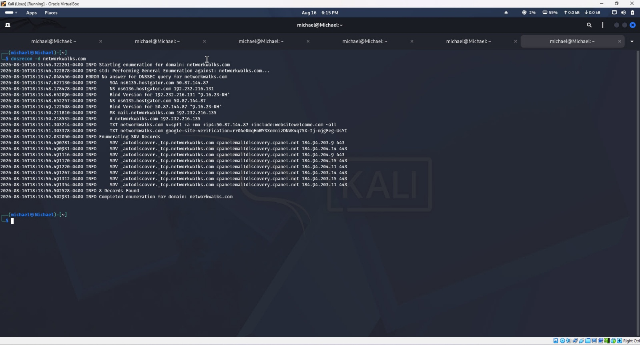
Figure 6 dnsrecon scan on networkwalks.com

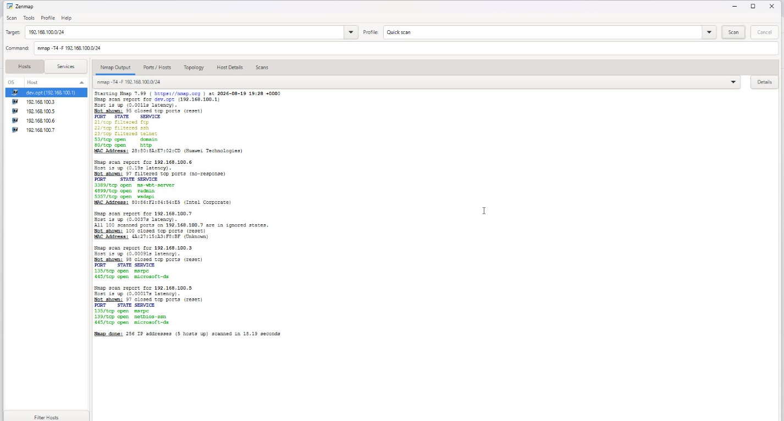
Figure 7 Network Scan Result

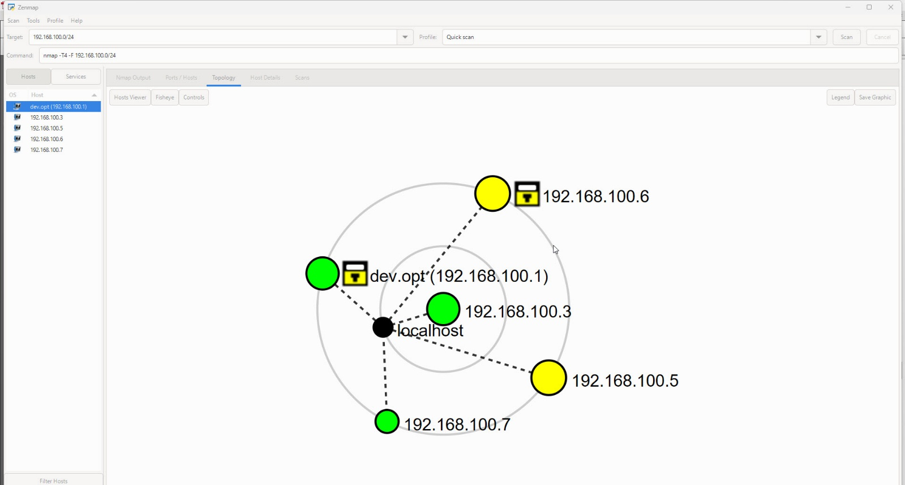
Figure 8 Topology of scan network

👤 Author
Michael Tetteh
Cybersecurity Professional B083
LinkedIn: www.linkedin.com/in/michael-tetteh-602721322

📌 Project Information
Program Name: Cybersecurity program at Networkwalks | Week: 02 |
Repository: https://github.com/malavanyo11-source

